Title of Student Paper

Student Name
Department Name, Clackamas Community College
Course Number and Name for which the paper is being submitted
Instructor Name
Assignment due date written in Month Date, Year

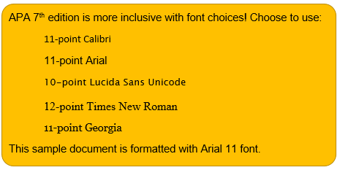

Title of Student Paper
The title of your paper appears at the top of the first page of the body of your paper (page 2, in this case). The title is always bolded.
Indentations, Margins, Alignment, and Spacing
Indent every paragraph 0.5 inch (not five spaces). Use 1-inch margins on the top, bottom, left, and right of each page. Use 0.5 inch margins for a header and footer. Left-align your APA paper. Leave the right alignment “ragged”; do not right-justify your paper.
Double space every paragraph; make sure there are no extra spaces between paragraphs. MS Word’s default is to add extra space between paragraphs when you hit “Enter.” You’ll need to undo that default in Word’s Paragraph toolbox.
Headings (Level 1 Heading)
Use descriptive headings to organize sections of your paper. APA student papers may have some or all of the following sections: an introduction with a research question or thesis, background about the topic, current findings, your analysis or discussion of the topic, further research needed or unanswered questions, and a conclusion. Learn about headings and when to use them on pages 47-49 of the APA Publication Manual (7th ed.). This template illustrates two levels of headings: Level 1 and Level 2.
Citing and Formatting In-text Citations
Whenever you include an idea in your paper that is not originally your own, be sure to attribute that information to the original author(s). This practice is called citing. It is also called avoiding plagiarism! Citing has two parts: a short citation in-text and a more complete citation at the very end of your paper, on your References page. In-text citations consist of the author's last name, followed by year of publication. Citations may be written into a sentence in narrative format using a signal phrase, which is a phrase that helps introduce the idea. Or, citations can be included within parentheses at the end of a sentence, using a parenthetical citation. Here are examples of both formats:
In-Text Citations in Narrative Format Using Signal Phrases (Level 2 Heading)
Stanbury and Briskie (2023) reported that….
Adeyemi (2024) proposed….
According to Hernández et al. (2018), subjects were….
In-Text Citations in Parenthetical Format
The researchers found that [...] all chickens go to heaven (Rogers & Tran, 2020). In the signal phrase examples above, notice that the word “and” was spelled out when used in a sentence. In the parenthetical example, “and” was replaced by an ampersand (&) because the citation occurred within a parenthesis.
Quotations
Paraphrase or summarize authors’ ideas whenever possible, rather than including direct quotations. If you choose to include a direct quotation, place it inside quotation marks and “always provide the author, year, and page number of the quotation in the in-text citation” (American Psychological Association, 2020, p. 270). Remember that paraphrased and summarized ideas still require citations, but a page number is not necessary. Learn more about paraphrasing and quoting on pages 269-78 of the APA Publication Manual (7th ed.).
APA Help
If you need assistance with APA, use any of the following resources:
- American Psychological Association (APA) - apastyle.apa.org/style-grammar-guidelines
- CCC Writing Center - 503-594-6275, www.clackamas.edu/writingcenter
- CCC Library - 503-594-6042, libguides.clackamas.edu/citing/apa7
- Purdue Owl - https://owl.english.purdue.edu/owl
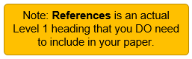
References
American Psychological Association. (2020). Publication manual of the American Psychological Association (7th ed.). https://doi.org/10.1037/0000165-000
Apardian, R. E., & Reid, N. (2023). Going out for a pint: Exploring the relationship between craft brewery locations and neighborhood walkability. Papers in Applied Geography, 6(1), 1-16. https://doi.org/10.1080/23754931.2019.1699151
Bauer, B. A. (2018, December 20). CBD: Safe and effective? Mayo Clinic. https://www.mayoclinic.org/healthy-lifestyle/consumer-health/expert-answers/is-cbd-safe-and-effective/faq-20446700
Clifford, S. (2011, December 28). Training a cat to walk on a leash. The New York Times. https://www.nytimes.com/2011/12/29/garden/training-a-cat-to-walk-on-a-leash.html
Frank, H. J. [zefrank1]. (2020, January 17). True facts: The ostrich [Video]. YouTube. https://youtu.be/1YTeasbvJ2E
Pesznecker, S. C. (2024, May 28). Examining the intersection of standard poodles and publication manuals [PowerPoint slides]. Moodle, Clackamas Community College. https://online.clackamas.edu
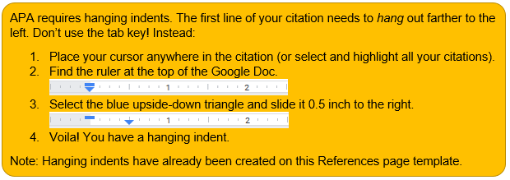
Schein, E. H., & Schein, P. A. (2016). Organizational culture and leadership (5th ed.). John Wiley & Sons, Inc.

